
SUBJECT:
SOFTWARE C&D
2nd

LAB TASK:
MR MUHAMMAD EJAZ
SUBMITTED TO:
AFTAB GHANI
SUBMITTED BY:
DEPARTMENT:
SOFTWARE ENGINEERING
CU ID:
4329-2023

SEMESTER:
5TH
DATE:
28-11-2025

CECOS UNIVERSITY OF IT & EMERGING SCIENCE HAYATABAD, PESHAWAR

LAB 02
1. Create a tuple with 10 elements i-e- include Int, Float and String values.by the user.
Code:
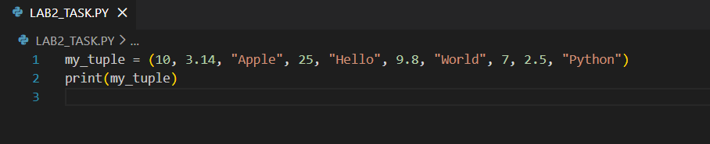
Output:

2. Count a specific element that how many times appears in a tuple using count().
Code:
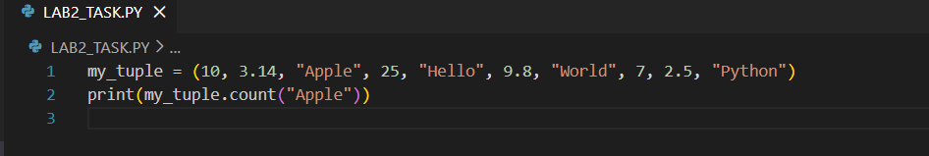
Output:

3. WAP which Convert tuple to list, modify it, and convert it back to a tuple.
Code:
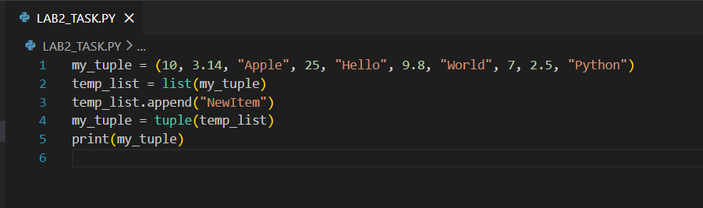
Output:

4. Create a nested tuple and access elements from the inner tuple.
Code:
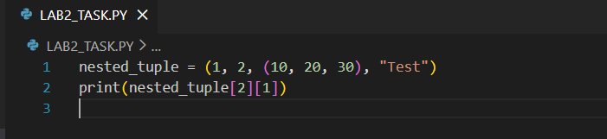
Output:

5. Def a set of 7 elements i-e- include Int, Float and String values.
Code:
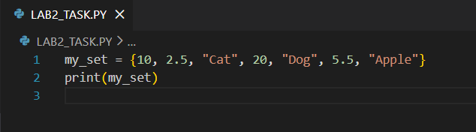
Output:

6. Add a new element to a set using add() and multiple elements to a set using update().
Code:
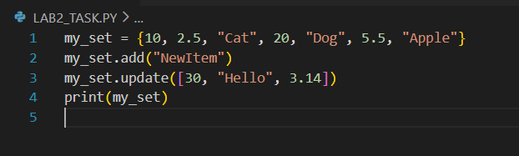
Output:
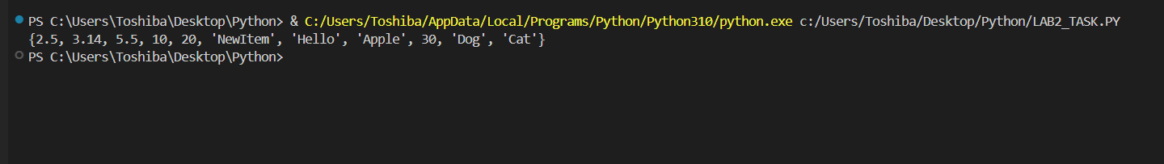

7. Remove an element from a set using both remove() and discard().
Code:
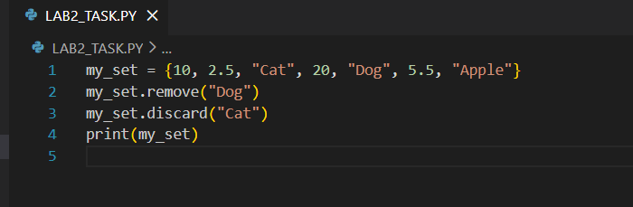
Output:
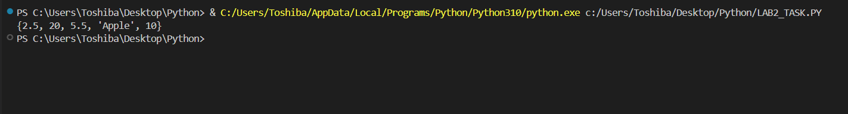

8. Define two sets and find their union using union().
Code:
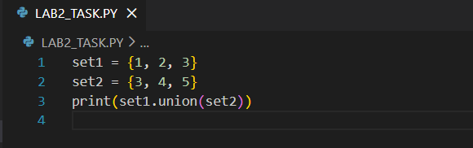
Output:

9. define two sets and find their intersection using intersection().
Code:
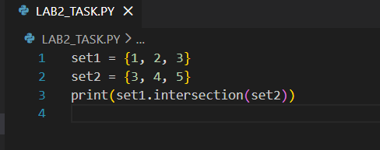
Output:
10. Create a dictionary of 3 students with their marks and print each key-value pair.
Code:
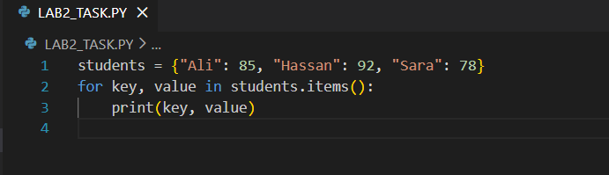
Output:
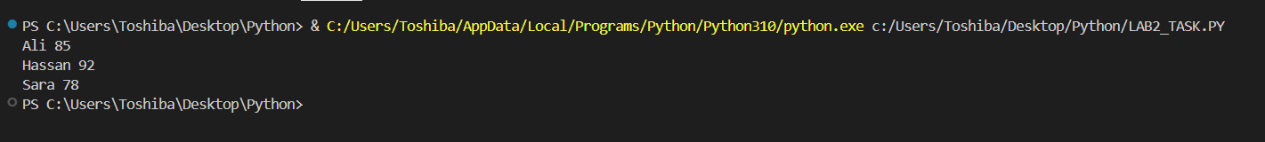

11. Write a program to add a new key-value pair to a dictionary.
Code:
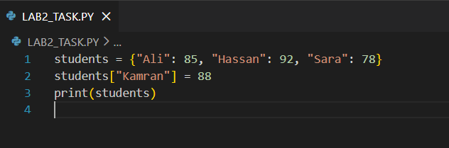
Output:

12. WAP to Access a value from the dictionary using its key.
Code:
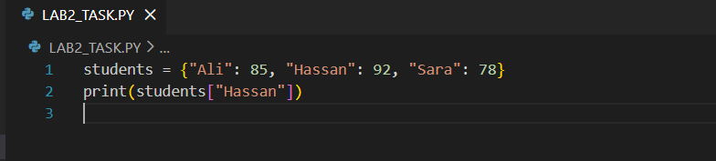
Output:

13. WAP to Add a new key-value pair to a dictionary using assignment.
Code:
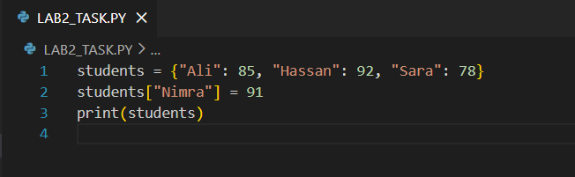
Output:

14. WAP to Update an existing value in a dictionary.
Code:
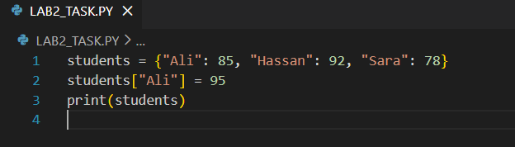
Output:

15. WAP to Remove a key-value pair using pop() and del.
Code:
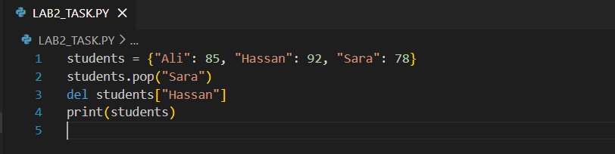
Output:

16. Use .items() to print both keys and values in a loop.
Code:
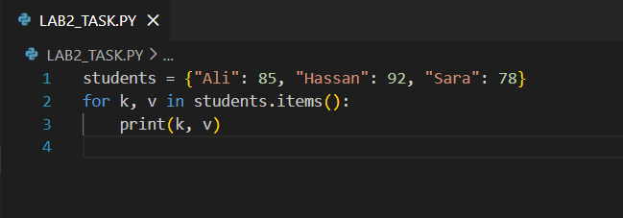
Output:
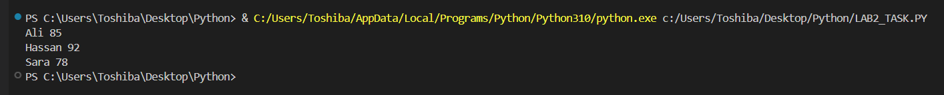

17. Find the number of items in a dictionary using len().
Code:
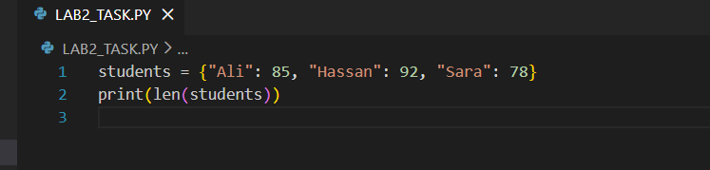
Output:

18. Merge two dictionaries using the update() method.
Code:
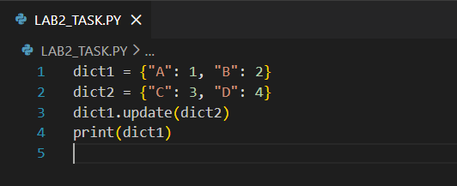
Output:

